Push & Pull Documentation

ALWAYS PULL THE REPOSITORY BEFORE YOU PUSH ANY CHANGES!!! HERE’S HOW:

How to pull the GitHub repository:

1. Click the Source Control button on the middle left

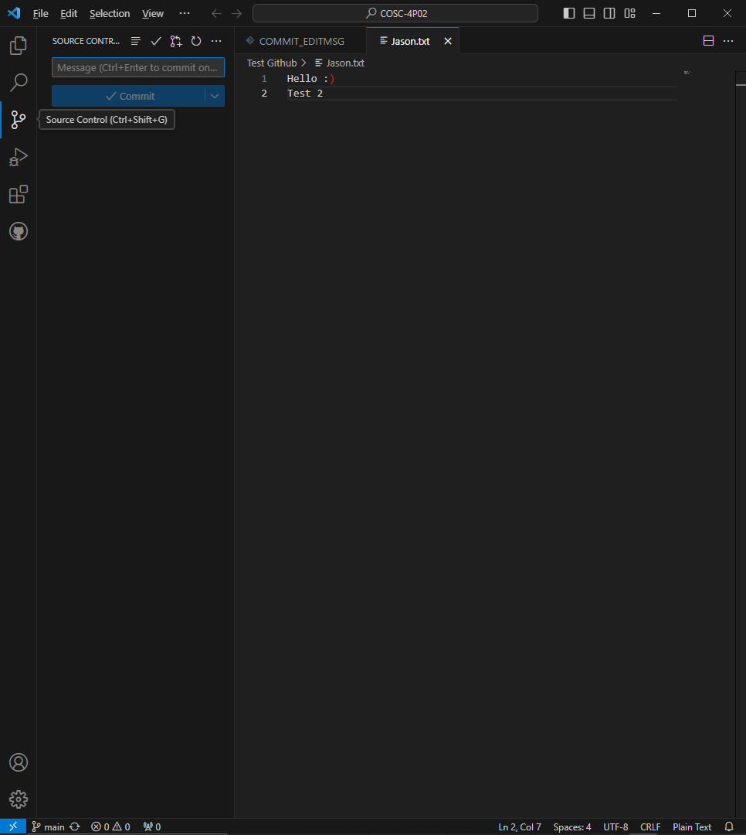

1. Click the 3 dots on the top right of the source control panel

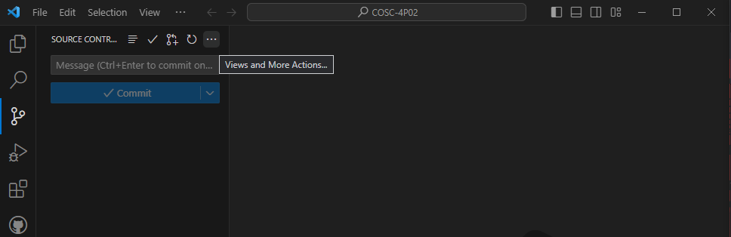

1. Click pull. This will pull the most recent version of the project.

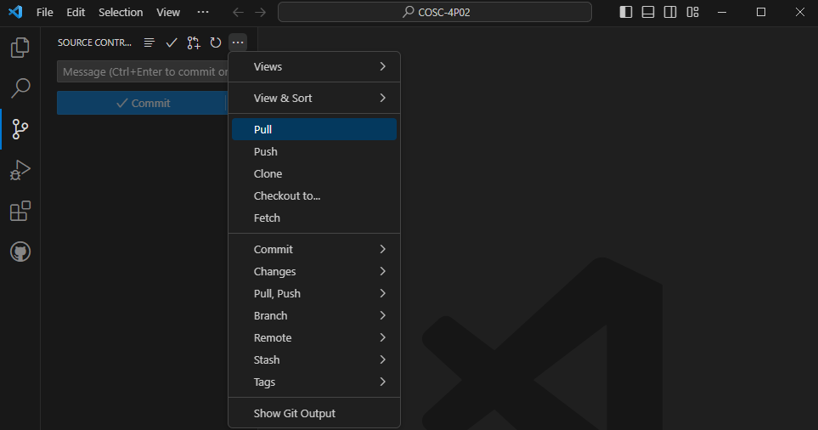

How to push to the GitHub repository (must have pulled first):

1. Click the Explorer button on the top left

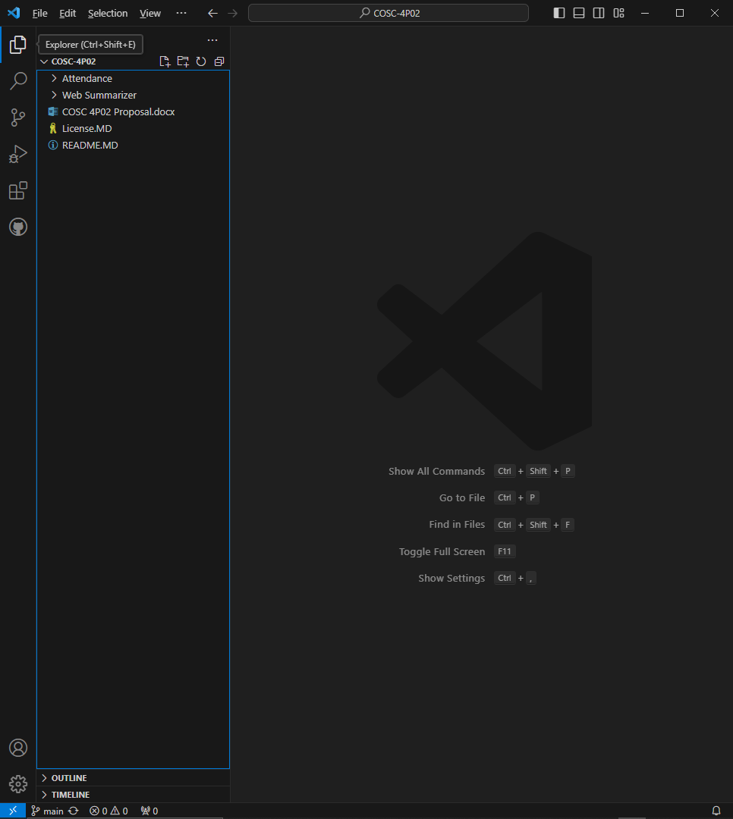

1. Add your changes to the repository
2. Go back to Source Control (the button on the middle left)

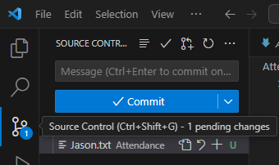

1. Click the blue and white drop-down arrow on the right side of commit

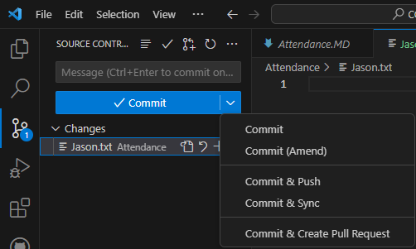

1. Click the “Commit & Push” button

